**1 OBJECTIVE**

* 1. **PROJECT OBJECTIVE**

1. Online Book Donation System is non-profit organizational web project by this project any user can donate their books to other needy person.
2. Any user who want to donate their books, so he/she can fill online book donation form and donate their book.
3. User friendly prompts are provided for user..
4. Data reports allow generation of reports dynamically with desired query.
5. Attractive and catch graphical and photographic interfaces are used for user interaction.

**1.2 PURPOS & DROWBACK OF EXISTING SYSTEM**

**1.2.1 PURPO SE**

Online book donation system provides a platform for all the people who need books, stationery and cannot afford it and also for people who want to give away their unused books or books that are no longer required by them.

**2 DRAWBACK OF EXISTINGSYSTEM**

We just can search who want to donate their books by manual search capacity but its not necessary we can succeed so this is a waste of time.

**1.3 PROPOSED SYSTEM**

1. with the web application first user must create his/her account on our application. After login, user can donate their books through our application.

2. very easy to use and safe.

3. Reduce the cost of maintaining system.

**ADVANTAGES**

1. You can save valuable time with automated functionality

2. Not manual work is involved.

3.Time to time information verified by the organization to Ensure data accuracy.

4. User friendly system.

5. Optimize processing time.

**1.4 FEATURES**

1. Online Book Donation System expect online giving features that will allow them to donate online and have access to their giving records when they need it

2. Having this data all in one place is critical to understanding your donors better, helping you improve your relationships and optimization.

.

* 1. **SCOPE OF PROJECT**

The system could be a boon in the education system as the book could be reused at a larger scale

And also it would help in the saving environment as million of trees cut every year to get paper.

# 2. INFORMATION GATHERING

Good information gathering can make the difference between a successful project and one that has failed to provide maximum benefit to the user. Information can be found on the organization's website, trade papers, Usenet, financial databases, or even from disgruntled employees. Some potential sources are discussed.

# 2.1 SOURCE OF INFORMATION

# An information source is a source of information for somebody, i.e. anything that might inform a person about something or provide knowledge about it. Different types of questions require different sources of information. Information sources may be observations, people, speeches, documents, pictures, organizations, websites, etc. They may be primary sources, secondary sources, tertiary sources and so on.

# 2.2 STEPS FOR INFORMATION COLLECTION

# STEP1:Recognize your need for information

# An information literate person is able to recognize his/her need for information.

For example: When you get an assignment from a lecturer.

We have need information about school.

# STEP2:Think about and analyses

Identify the main ideas and keywords in the question.

Example: “Discuss the selection criteria and selection aids used in selecting books for a library.”

Now we think about relevant information.

**2.3 TECHNIQUE FOR COLLECT INFORMATION**

The following table provides an overview of the basic techniques to collect information.

|  |  |  |  |
| --- | --- | --- | --- |
| **Method** | **Overall Purpose** | **Advantages** | **Challenges** |
| questionnaires, surveys, checklists | when need to quickly and/or easily get lots of information from people in a non threatening way | -can complete anonymously -inexpensive to administer -easy to compare and analyze -administer to many people -can get lots of data -many sample questionnaires already exist | -might not get careful feedback -wording can bias client's responses -are impersonal -in surveys, may need sampling expert - doesn't get full story |
| documentation review | when want impression of how program operates without interrupting the program; is from review of applications, finances, memos, minutes, etc. | -get comprehensive and historical information -doesn't interrupt program or client's routine in program -information already exists -few biases about information | -often takes much time -info may be incomplete -need to be quite clear about what looking for -not flexible means to get data; data restricted to what already exists |

**3. DEFINE TOOLS**

**3.1 S/W & H/W SPECIFICATIONS**

**HARDWARE & SOFTWARE SPECIFICATION**

Ram : 1Gb

OS : Window 2008, 2010

Development tools : NetBeans, Eclipse, Notepad, WordPad

Database : MySQL

Server : Apache

Client : Chrome, Firefox

**3.2 DBMS TOOLS**

For a database administrator, DBM (database management) tools make tasks related to maintaining relational databases efficient and fast. Prior to the popularity of these tools, most DBA’s had to use the command line to create, edit, and delete databases.

Here is some Database management Systems (DBMS) Tools just like as:

1. MySQL

**3.2.1 FRONT END TOOLS**

Front end tools are the tools which are used to design the user interface of the application.

Here is some Front End Tools just like as:

1. JSP
2. HTML

**3.3 DATA PREPARATION TOOLS**

Data Preparation Tool helps users in preparing case sets of data for data mining purposes.

1. The purpose of preparation is to transform data sets so that their information content is best exposed to the mining tool.

2. Error prediction rate should be lower (or the same) after the preparation as before it.

3. Data need to be formatted for a given software tool

4. Data need to be made adequate for a given method

The Process of Data Preparation is as following:-

**3.3.1 DATA SELECTION**

Based on The Following Criteria:

* 1. Data quality properties:- Completeness and correctness
  2. Technical constraints such as limits on data volume or data type: - Related to data mining tools

**3.3.2 DATA CLEANING**

Possible Techniques for Data Cleaning:

Data normalization.:E.g., decimal scaling into the range (0, 1) by mapping, or standard deviation normalization.

Data smoothing.:E.g. Discretization of numeric attributes, this is helpful or even necessary for logic based methods.

Treatment of missing values. :Predict missing values & replace them with the east biased values. E.g. preserve the relationship between variables.

Data Reduction.:The most usual step: examine the attributes and consider their predictive potential.

E.g. attribute selection from means and variances, merging features using linear transform.

**3.3.3 NEW DATA CONSTRUCTION**

Constructive Operations on Selected Data Include:

1. Derivation of new attributes from the existing attributes.

2 .Generation of new records.

3.Data Transformation.

4.Merging Tables.

5.Aggregation: Summarizing information from multiple records and/or tables.

**3.3.4 DATA FORMATTING**

It Involves Syntactic Modification Required by Modeling Tools:

1.Reordering of the attributes or records.

2.Changes related to the constraints of the modeling tools: e.g. removing comma or tabs, trimming strings to maximum allowed number of characters, replacing special characters with allowed set of special characters.

**3.4 REPORTING TOOLS**

Reporting tools are used in government, business, education, science, software, construction and other fields. They often use graphics, images, voice, or specialized representation in order to explain and accordingly undertake an action. In addition, it visually represents the project status, length of an activity and time spent on it.

* + 1. **BENEFITS OF PROJECT REPORTNG TOOLS**

1.Allows you to identify the resources needed to complete a project.

2.Helps you to monitor whether the project is on schedule or not

3.Gain visibility into how your team is progressing against pre-defined goals.

**3.5 TESTING TOOLS**

Testing tools are a form of automated testing. It is basically using programs to do different testing tasks i.e. doing the tests through some form of automated method. They are computerized and help in assisting every type of testing. Some of these testing tasks include checking the conditions, also checking the predicted results with the actual results along with many other types of testing involved. A lot of these testing tools have commonly used coding languages such as Java and C. The testing tools themselves have been made using these programming languages. A lot of the tools used have different options available to help with testing. This can be very useful when producing the essential reports of that particular product.

**TYPES OF TESTING**

There are many different types of testing tools. Each different testing tool is capable of doing different things as each one has different abilities to do different things. These are considered to be in the testing tools environment... Below is a list of each one available and an explanation of what they do.

**3.5.1 UNIT TESTING TOOLS**

This is used in the testing process of the method. This testing is on the developer end. When we code any module and when we forward it to testing team at first we do unit testing then forward it.

**3.5.2 REGRESSION TESTING TOOLS**

Many different tools can be used for regression. It helps to automate the testing as the program can be reused. An example of a program is configuration testing which is a program that is run with a new version of the operating system with a new application.

**3.5.3 WEB TOOLS**

This is used over web based applications. It tests for bugs and problems that appear within the application. An example of this may be that once a problem is detected such as having dead links, line checking or html validation then it provides help in repairing this problem.

**3.5.4 SECURITY TESTING TOOLS**

These can help aid with the security of the system. It can help against unauthorized access, hacking and any coding damage which deals with the code of application. It uses very sophisticated testing techniques. QA inspect is a very good program to use for this type of testing.

**4. FEASIBILITY STUDY**

The data collection that occurs during the Initial Investigation examines system feasibility. There are three tests of feasibility namely technical, operational and economic.

**4.1 TYPE OF FEASIBILITY STUDY**

**4.1.1 TECHNICAL FEASIBILITY**

It involves determining whether or not a system can actually be constructed to solve the problem at hand.

Technically the system is feasible due to the following:

**1.** The necessary technology exists that is needed for the system.

**2.** The system has technical capacity to hold the required data**.** If the system is developed,

it can be further expanded

**3.** There is data security in the system.

**4.1.2 OPERATIONAL FEASIBILITY**

Proposed projects are beneficial only if they can be turned into information systems that will meet the organization's operating requirements. Simply stated, this test of feasibility asks if the system will work when developed and installed. System is made menu driven. Hence time consumption in operation of the system is less and easy for them and users to operate. Each and every step in the system is user Friendly hence no extra computer literacy is required while handling the system.

**4.1.3 ECONOMICAL FEASIBILITY**

All the hardware and Software Facilities as available with the end user so the cost if hardware and software implementation is eradicated. The operational cost is also minimized, as no special computer training is essential. As the new system does not demand any Investments for the operation of the system. The only cost is the development cost, which negligible. Therefore system is economically Feasible for end user.

**4.2 COST BENEFIT ANALYSIS**

**Cost benefit analysis** (CBA), sometimes called **benefit–cost analysis** (BCA), is a systematic process for calculating and comparing benefits and costs of a project, decision or [government policy](http://en.wikipedia.org/wiki/Government_policy) (hereafter, "project"). CBA has two purposes:

1.To determine if it is a sound investment/decision (justification/feasibility),

2.To provide a basis for comparing projects. It involves comparing the total expected cost of each option against the total expected benefits, to see whether the benefits outweigh the costs, and by how much.

CBA is related to, but distinct from [cost-effectiveness](http://en.wikipedia.org/wiki/Cost-effectiveness) analysis. In CBA, benefits and costs are expressed in monetary terms, and are adjusted for the [time value ofmoney](http://en.wikipedia.org/wiki/Time_value_of_money), so that all flows of benefits and flows of project

costs over time (which tend to occur at different points in time) are expressed on a common basis in terms of their "[net present value](http://en.wikipedia.org/wiki/Net_present_value)."

**4.2.1 PROCESS**

The following is a list of steps that comprise a generic cost-benefit analysis.

1.List alternative projects/programs.

2.Select measurement(s) and measure all cost/benefit elements.

3.Predict outcome of cost and benefits over relevant time period.

4.Convert all costs and benefits into a common currency.

5.Apply [discount rate](http://en.wikipedia.org/wiki/Discount_rate).

6.Calculate [net present value](http://en.wikipedia.org/wiki/Net_present_value) of project options.

7.Perform [sensitivity analysis](http://en.wikipedia.org/wiki/Sensitivity_analysis).

8.Adopt recommended choice.

**4.2.2 VALUATION**

CBA attempts to measure the positive or negative consequences of a project, which may include:

1.Effects on users or participants

2.Effects on non-users or non-participants

3.[Externality](http://en.wikipedia.org/wiki/Externality) effects

4.[Option value](http://en.wikipedia.org/wiki/Option_value) or other social benefits

**4.2.3 TIMES AND DISCOUNTING**

CBA usually tries to put all relevant costs and benefits on a common temporal footing using [time value of money](http://en.wikipedia.org/wiki/Time_value_of_money) calculations. This is often done by converting the future expected streams of costs and benefits into a [present value](http://en.wikipedia.org/wiki/Present_value) amount using a [discount rate](http://en.wikipedia.org/wiki/Discount_rate). Empirical studies and a technical frame work suggest that in reality, people do discount the future like this.

The choice of discount rate is subjective. A smaller rate values future generations equally with the current generation. Larger rates (e.g. a market rate of return) reflects humans' attraction to [time inconsistency](http://en.wikipedia.org/wiki/Time_inconsistency)—valuing money that they receive today more than money they get in the future.

**4.2.4 RISK AND UNCERTAINITY**

Risk associated with project outcomes is usually handled using probability theory. This can be factored into the discount rate (to have uncertainty increasing over time), but is usually considered separately. Particular consideration is often given to [risk aversion](http://en.wikipedia.org/wiki/Risk_aversion)—the irrational preference for avoiding loss over achieving gains. [Expected return](http://en.wikipedia.org/wiki/Expected_return) calculations does not account for the detrimental effect of uncertainty.

Uncertainty in CBA parameters (as opposed to risk of project failure etc.) can be evaluated using a sensitivity analysis, which shows how results respond to parameter changes.

**5. SOFTWARE REQUIREMENT SPECIFICATION**

The software requirements specification is produced at the culmination of the analysis task. The function and performance allocated to the software as a part of system engineering are refined by establishing a complete information description, a detailed functional and behavioral description, and indication of performance requirements and design constraints, appropriate validation criteria and other data pertinent to requirements

Software Requirements Specification plays an important role in creating quality software solutions. Specification is basically a representation process. Requirements are represented in a manner that ultimately leads to successful software implementation Specification is the process of breaking a complex topic into smaller parts to gain a better understanding of it. Requirements Specification is the process of understanding the needs and expectations from a proposed system or application and is a well-defined stage in the Software Development model. Requirements are a description of how a system should behave or a description of system properties or attributes. It can alternatively be a statement of ‘what’ an application is expected to do. The Software Requirements Specification Process covers the complex task of eliciting and documenting the requirements of all these users, modeling and analyzing these requirements and documenting them as a basis for system design. A dedicated and specialized Requirements Analyst is best equipped to handle the job. Software Requirements Specification and Documentation Processes are critical to software project success. The questions to be answered at each stage of development were in hand analyzed like what are the basic hardware and software specifications required to develop the project, what the user is required to possess in basic, the context of the project and accordingly made it successful by implementing with the appropriate and reliable fulfillment of the requirements.

This project **“ONLINE BOOK DONATION SYSTEM”** has been developed in  **JSP,HTML** language**(**used as front-end).

The project has been developed with the help of Relational Database Management System (Parse DB) as back-end. The project stores the necessary details of all Social Networking. The project computerizes all the activities of communicating and sharing information with appropriate way.

In this we analyses what is the basic tools for designing our application.

**5.1 OVERVIEW OF JSP**

**JavaServer Pages** (**JSP**) is a technology that helps [software developers](https://en.wikipedia.org/wiki/Software_developer) create [dynamically generated web pages](https://en.wikipedia.org/wiki/Dynamic_web_page) based on [HTML](https://en.wikipedia.org/wiki/HTML), [XML](https://en.wikipedia.org/wiki/XML), or other document types. Released in 1999 by [Sun Microsystems](https://en.wikipedia.org/wiki/Sun_Microsystems), JSP is similar to [PHP](https://en.wikipedia.org/wiki/PHP) and [ASP](https://en.wikipedia.org/wiki/Active_Server_Pages), but it uses the [Java programming language](https://en.wikipedia.org/wiki/Java_(programming_language)).

To deploy and run JavaServer Pages, a compatible web server with a [servlet container](https://en.wikipedia.org/wiki/Servlet_container), such as [Apache Tomcat](https://en.wikipedia.org/wiki/Apache_Tomcat) or [Jetty](https://en.wikipedia.org/wiki/Jetty_(web_server)), is required.

Architecturally, JSP may be viewed as a high-level [abstraction](https://en.wikipedia.org/wiki/Abstraction_(computer_science)) of [Java servlets](https://en.wikipedia.org/wiki/Java_servlet). JSPs are translated into [servlets](https://en.wikipedia.org/wiki/Java_Servlet) at runtime, therefore JSP is a Servlet; each JSP servlet is cached and re-used until the original JSP is modified.

JSP can be used independently or as the view component of a server-side [model–view–controller](https://en.wikipedia.org/wiki/Model%E2%80%93view%E2%80%93controller) design, normally with [JavaBeans](https://en.wikipedia.org/wiki/JavaBeans) as the model and Java servlets (or a framework such as [Apache Struts](https://en.wikipedia.org/wiki/Apache_Struts)) as the controller. This is a type of [Model 2](https://en.wikipedia.org/wiki/JSP_model_2_architecture) architecture.

JSP allows Java code and certain pre-defined actions to be interleaved with static web markup content, such as HTML, with the resulting page being compiled and executed on the server to deliver a document. The compiled pages, as well as any dependent Java libraries, contain Java bytecode rather than [machine code](https://en.wikipedia.org/wiki/Machine_code). Like any other Java program, they must be executed within a [Java virtual machine](https://en.wikipedia.org/wiki/Java_virtual_machine) (JVM) that interacts with the server's host [operating system](https://en.wikipedia.org/wiki/Operating_system) to provide an abstract, platform-neutral environment.

JSPs are usually used to deliver HTML and XML documents, but through the use of OutputStream, they can deliver other types of data as well.

The [Web container](https://en.wikipedia.org/wiki/Web_container) creates JSP implicit objects like request, response, session, application, config, page, pageContext, out and exception. JSP Engine creates these objects during translation phase.

**5.1.2 EXAMPLE CODE**

<!DOCTYPE html>

<html>

<head>

<title>JSP Test</title>

</head>

<body>

<p>Counting to three:</p>

<% for (int i=1; i<4; i++) { %>

<p>This number is <%= i %>.</p>

<% } %>

<p>OK.</p>

</body>

</html>

**5.1.3 FOUNDATION FRAMEWORK**

Foundation Framework provides large set of features and they are listed below.

1.It includes a list of extended datatypes like NSArray, NSDictionary, NSSet and so on.

2.It consists of a rich set of functions manipulating files, strings, etc.

3.It provides features for URL handling, utilities like date formatting, data handling, error handling, etc.

**5.1.4 LEARNING JSP**

The most important thing to do when learning JSP is to focus on concepts and not get lost in language technical details.

The purpose of learning a programming language is to become a better programmer; that is, to become more effective at designing and implementing new systems and at maintaining old ones.

Before you start learning JSP you need a basic understanding of HTML. If you already have it, great. If not there are plenty of HTML [articles](https://www.thoughtco.com/what-you-can-do-with-html-3466578) and tutorials to help you. When you know both languages, you can switch between JSP and HTML right in the same document. You can even run JSP [from an HTML](https://www.thoughtco.com/execute-php-from-a-html-file-2693780) file.

**5.1.5 USE OF JSP**

JSP is a programming language used to enhance websites built with HTML. It is server-side code that can add a log-in screen,

1.JSP is mostly used for server side programming in web applications.

2.it can also be used for other things like general purpose programming or even for building desktop GUI applications.

3.It can also be used for [command-line](https://en.wikipedia.org/wiki/Command-line) scripting and [client-side](https://en.wikipedia.org/wiki/Client-side)[graphical user interface](https://en.wikipedia.org/wiki/Graphical_user_interface) (GUI) applications

4.It is available free of charge, and the JSP Group provides the complete source code for users to build, customize and extend for their own use.

5.JSP is commonly used in this bundle alongside [Linux](https://en.wikipedia.org/wiki/Linux), [Apache](https://en.wikipedia.org/wiki/Apache_HTTP_Server) and [MySQL](https://en.wikipedia.org/wiki/MySQL), although the *P* may also refer to [Python](https://en.wikipedia.org/wiki/Python_%28programming_language%29), [Perl](https://en.wikipedia.org/wiki/Perl), or some mix of the three.

**6. SYSTEM ANALYSIS**

Main aim of system analysis is to specify functional and non-functional requirements of the system are described and modeled using UML models.

**6.1 FUNCTIONAL REQUIREMENTS**

1. The functional requirements of the system are:
2. Register the user,
3. Records of tourist information,
4. Generate tourist tourism reports,
5. Generate timetable,

**6.2 NON FUNCTIONAL REQUIREMENTS**

Security requirements are important factors in this system as classified data will be stored in the database. User validation will be done during login to insure that the user is valid and that the user only has access to his or her permission data. General users will only have access through the user interface. The system will have consistent interface formats and button sets for all forms in the application, will have a form based interface for all data entry and viewing formats, and will generate reports that are formatted in a table and that should look like the existing manual report formats for users. The system will be easily maintained by the developer or other authorized trained person and it shall respond as fast as possible in generating report and producing the timetable.

**6.3 ANALYSIS MODEL**

To produce a model of the system which is correct, complete and consistent we need to construct the analysis model which focuses on structuring and formalizing the requirements of the system. Analysis model contains three models: functional, object and dynamic models. The functional model can be described by use case diagrams. Class diagrams describe the object model. Dynamic model can also be described in terms of sequence, state chart and activity diagrams. For the purpose of this project we have described the analysis model in terms of the functional model and dynamic models using use case and sequence diagrams.

**CLASS DIAGRAM:**

Student

Name : String

Email: String

Mobile:Big int

Address:String

Remove();

Add();

Update();

Checkout();

Book Donor

Name : String

Email: String

Mobile:Big int

Insert()

Update()

updsat

Remove();

Add();

Update();

Checkout();

Book Donor

User Name : String

Mobile Number: Big int

Password : String

Show details

Name : String

Email: String

Mobile:Big int

Address:String

Find()

Update()

Books

Name : String

Email: String

Mobile:Big int

Address:String

Insert()

Update()

Confirm()

Cancle()

**USE CASE DIAGRAM:**

**Book**

Donor Student

**SEQUENCE DIAGRAM:**

Update Status

Donate

Show details

Register

Other info

detials

User Customer

Login

Update

record

View record

**7.DESIGN**

**7.1DFD LEVEL :0**

Login view details

User/Student

User/Donor

Show details

**7.2DFD LEVEL 1:**

Login

User

j

Register

Add Books

/Update

Book Status

Show details

**7.3E-R DIAGRAMS**

ER Diagrams represent the relationship between the entities. An ER diagram is composed of

1. Entity is shown by rectangle.
2. Attribute is shown by oval.
3. Relationships with rhombus.
4. Optional is shown by circle.
5. Compulsory with dash.
6. Primary key with underscore.

We can represent Entity Relationship diagrams in two methods. From ER diagrams as shown in Fig we can conclude Dependency, Association, Generalization and Realization.

E-R Diagram:

Books

Donation

Book Donor

Contact

Book Donee

Update Status

**7.4 DATA DICTIONARY**

The most important aspect of the system is data design. The data must be organized according to the system requirements. The database approach is used to store and organize the data in developing the system. The database is an integrated collection of data stored in different types of tables.

Some general objectives in establishing a database are as follows:

1.Integrating all data

2.Incorporate updations easily

3.Provide data security from unauthorized users

**7.4.1 TABLENAME:**User

|  |  |  |
| --- | --- | --- |
| FIELD | TYPE | KEY |
| NAME | STRING |  |
| PHONE | NUMBER | PRIMARY |
| PASSWORD | PASSWORD |  |

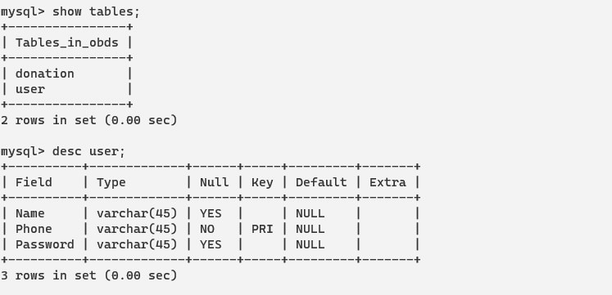

**7.4.2 TABLENAME:** Donation

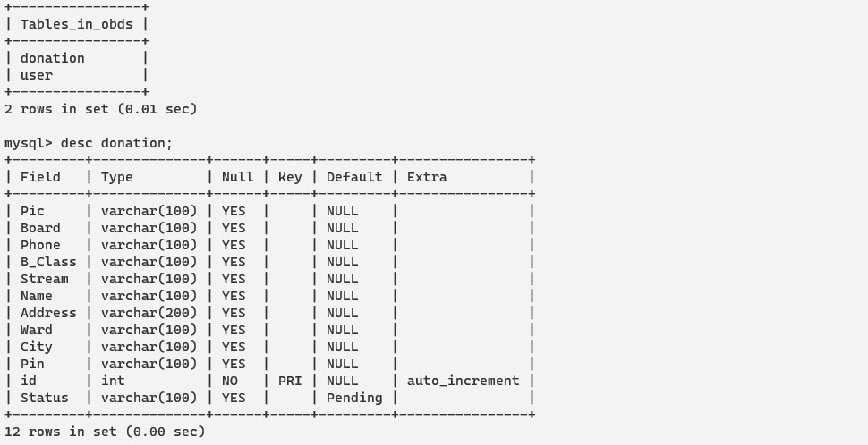

1. **IMPLEMENTATION**

**SCREEN SHOT:**

**HOME**

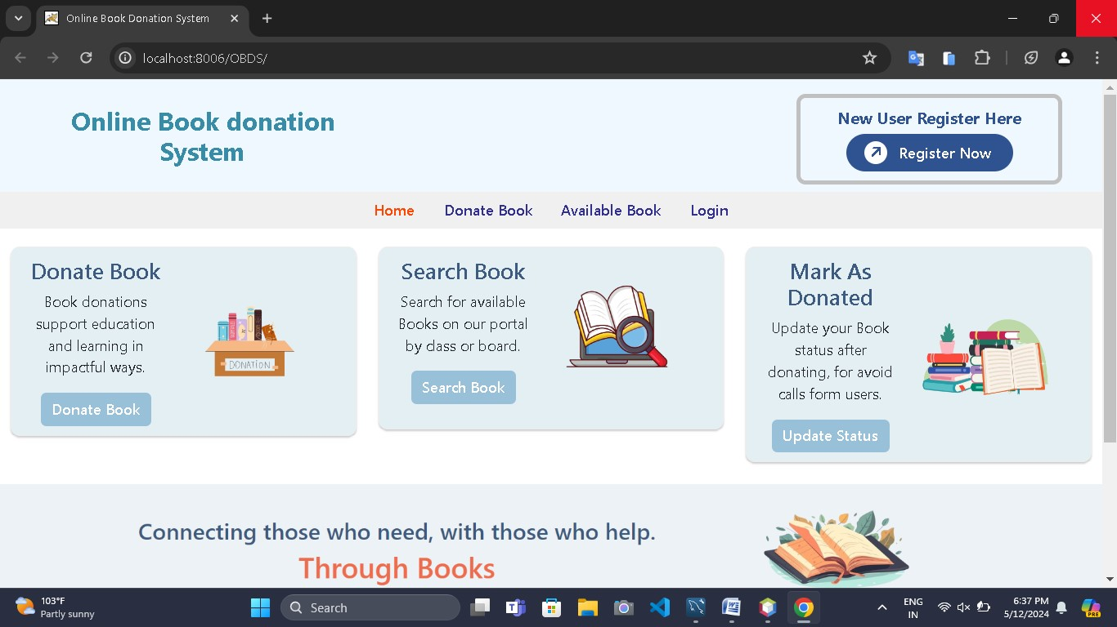

**LOGIN**

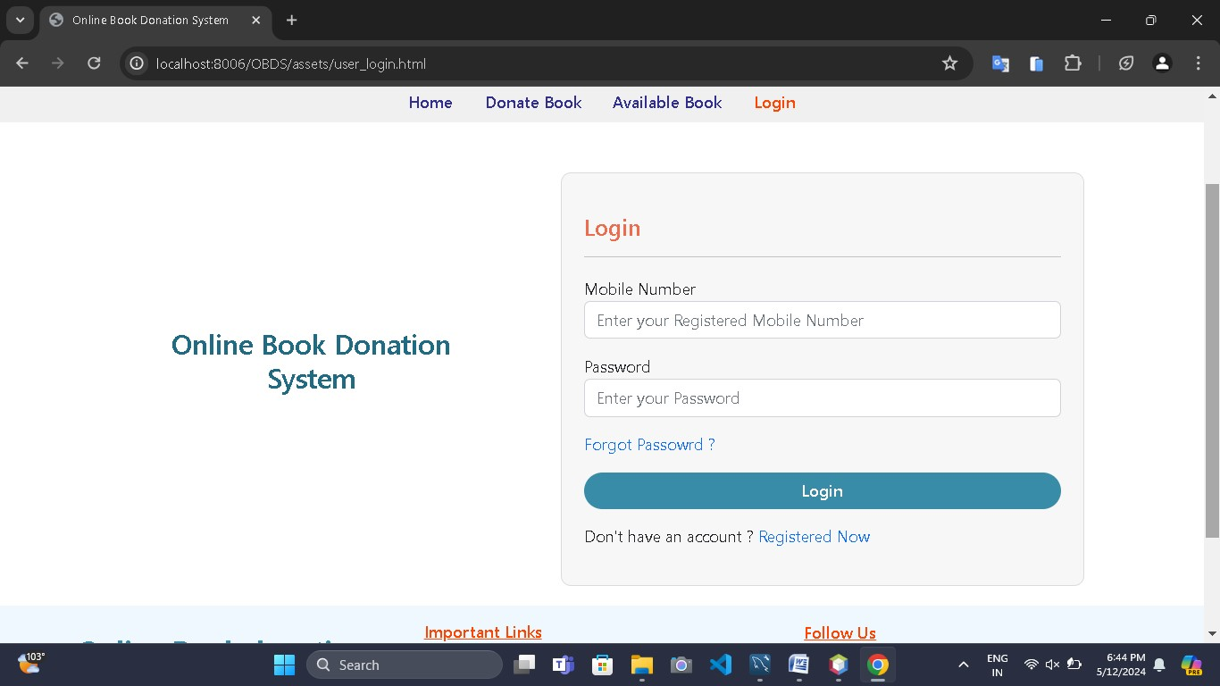

**REGISTER**

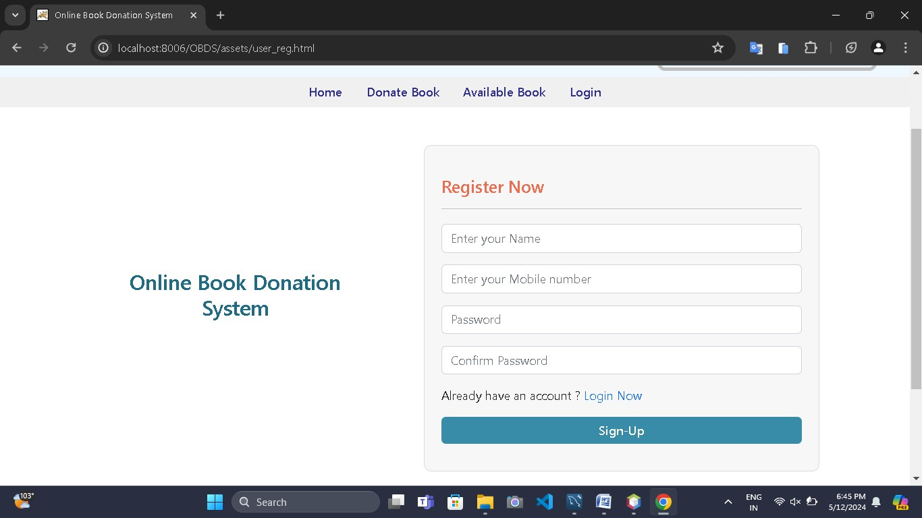

**AVAILABLE BOOK**

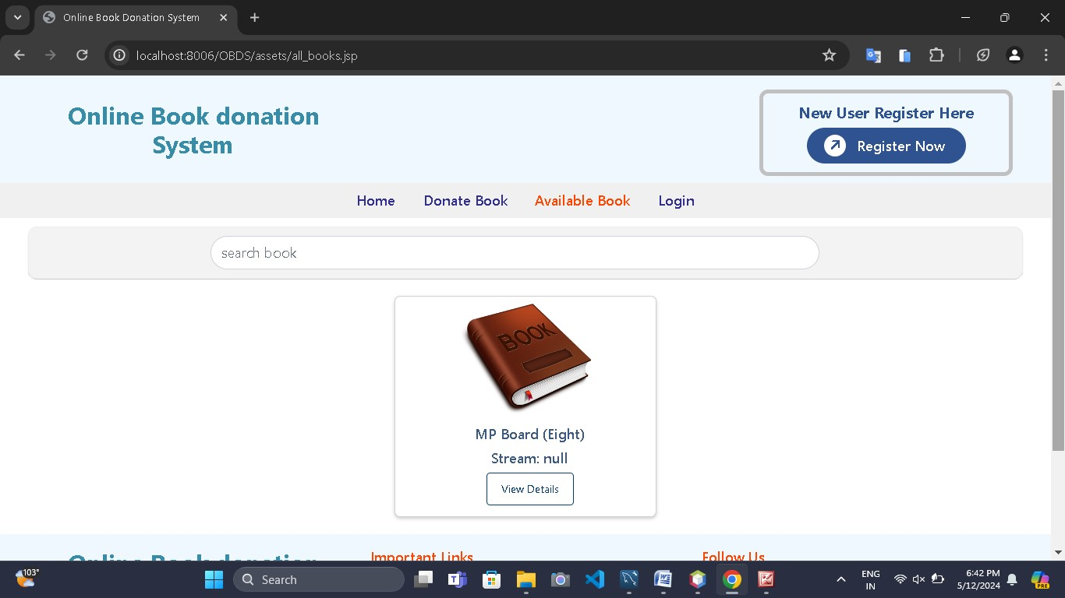

**UPDATE BOOK STATUS**

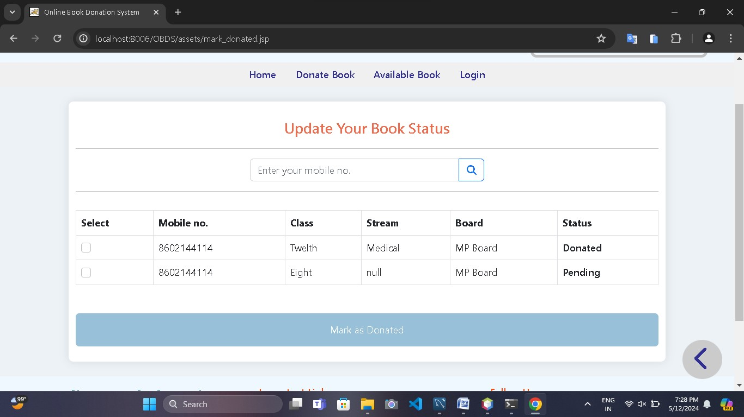

**USER DATABASE**

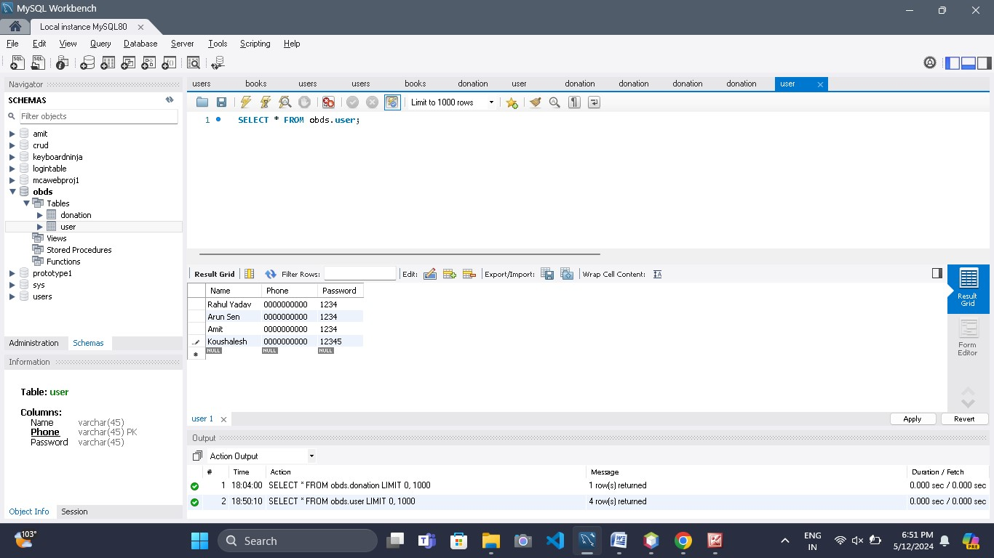

**DONATION DATABASE**

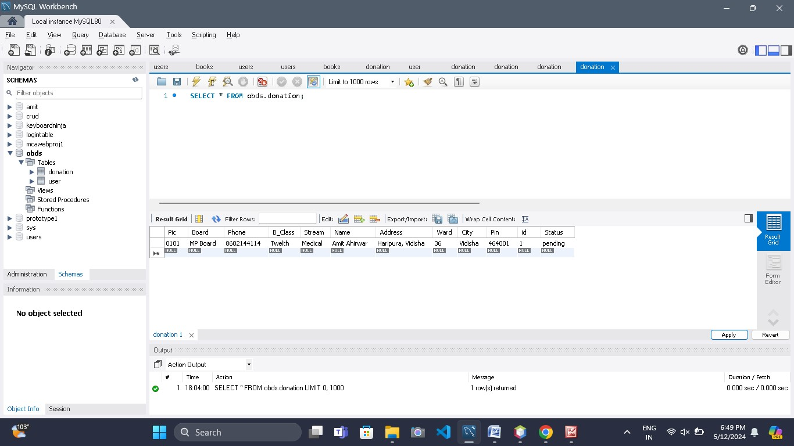

**9. TESTING**

Testing can either be done manually or using an automated testing tool:

**Manual** - This testing is performed without taking help of automated testing tools. The software tester prepares test cases for different sections and levels of the code, executes the tests and reports the result to the manager.

Manual testing is time and resource consuming. The tester needs to confirm whether or not right test cases are used. Major portion of testing involves manual testing.

**Automated** This testing is a testing procedure done with aid of automated testing tools. The limitations with manual testing can be overcome using automated test tools.

**9.1 TESTING APPROACHES**

Tests can be conducted based on two approaches –

1.Functionality testing

2.Implementation testing

When functionality is being tested without taking the actual implementation in concern it is known as black-box testing. The other side is known as white-box testing where not only functionality is tested but the way it is implemented is also analyzed.

Exhaustive tests are the best-desired method for a perfect testing. Every single possible value in the range of the input and output values is tested. It is not possible to test each and every value in real world scenario if the range of values is large.

### 9.2BLACK-BOX TESTING

It is carried out to test functionality of the program. It is also called ‘Behavioral’ testing. The tester in this case, has a set of input values and respective desired results. On providing input, if the output matches with the desired results, the program is tested ‘ok’, and problematic otherwise.

In this testing method, the design and structure of the code are not known to the tester, and testing engineers and end users conduct this test on the software.

Black-box testing techniques:

**1.Equivalence class** - The input is divided into similar classes. If one element of a class passes the test, it is assumed that all the class is passed.

**2.Boundary values** - The input is divided into higher and lower end values. If these values pass the test, it is assumed that all values in between may pass too.

**3.Cause-effect graphing** - In both previous methods, only one input value at a time is tested. Cause (input) – Effect (output) is a testing technique where combinations of input values are tested in a systematic way.

**4.Pair-wise Testing** - The behavior of software depends on multiple parameters. In pairwise testing, the multiple parameters are tested pair-wise for their different values.

**5.State-based testing** - The system changes state on provision of input. These systems are tested based on their states and input.

### 9.3WHITE-BOX TESTING

It is conducted to test program and its implementation, in order to improve code efficiency or structure. It is also known as ‘Structural’ testing.

In this testing method, the design and structure of the code are known to the tester. Programmers of the code conduct this test on the code.

The below are some White-box testing techniques:

**1.Control-flow testing** - The purpose of the control-flow testing to set up test cases which covers all statements and branch conditions. The branch conditions are tested for both being true and false, so that all statements can be covered.

**2.Data-flow testing** - This testing technique emphasis to cover all the data variables included in the program. It tests where the variables were declared and defined and where they were used or changed.

## 9.4 TESTING LEVELS

Testing itself may be defined at various levels of SDLC. The testing process runs parallel to software development. Before jumping on the next stage, a stage is tested, validated and verified.

Testing separately is done just to make sure that there are no hidden bugs or issues left in the software. Software is tested on various levels -

### UNIT TESTING

While coding, the programmer performs some tests on that unit of program to know if it is error free. Testing is performed under white-box testing approach. Unit testing helps developers decide that individual units of the program are working as per requirement and are error free.

### INTEGRATION TESTING

Even if the units of software are working fine individually, there is a need to find out if the units if integrated together would also work without errors. For example, argument passing and data updation etc.

### SYSTEM TESTING

The software is compiled as product and then it is tested as a whole. This can be accomplished using one or more of the following tests:

**1.Functionality testing** - Tests all functionalities of the software against the requirement.

**2.Performance testing** - This test proves how efficient the software is. It tests the effectiveness and average time taken by the software to do desired task. Performance testing is done by means of load testing and stress testing where the software is put under high user and data load under various environment conditions.

**3.Security & Portability** - These tests are done when the software is meant to work on various platforms and accessed by number of persons.

### ACCEPTANCE TESTING

When the software is ready to hand over to the customer it has to go through last phase of testing where it is tested for user-interaction and response. This is important because even if the software matches all user requirements and if user does not like the way it appears or works, it may be rejected.

**1.Alpha testing** - The team of developer themselves perform alpha testing by using the system as if it is being used in work environment. They try to find out how user would react to some action in software and how the system should respond to inputs.

**2.Beta testing** - After the software is tested internally, it is handed over to the users to use it under their production environment only for testing purpose. This is not as yet the delivered product. Developers expect that users at this stage will bring minute problems, which were skipped to attend.

### Regression Testing

Whenever a software product is updated with new code, feature or functionality, it is tested thoroughly to detect if there is any negative impact of the added code. This is known as regression testing.

**10 CHALLENGES AND ISSUES FACING DURING PROJECT LIFE CYCLE**

When we was working is on the system we faced many problems.

Agile is new for me and my team members so we face many problem in it. When we was working on the product backlog (in other SDLC is called Modules). There is a time limit and every and every product backlog is a individual system and it has its own working and some where it is input for next product backlog.

Agile is totally depend on time and scrum meetings.

**11 SUMMARY**

**11.1 ADVANTAGES**

|  |  |
| --- | --- |
| |  | | --- | | **1.** Centralized system for all customer  **2.** All information manage at one place   **3.** Better control is possible.  **4.** Economies in storage is possible. Goods in bulk will occupy less space.  **5.** Bigger storage enables better and more modern handling methods (mechanical or automatic). | |

|  |
| --- |
|  |

**11.2 LIMITATION OF THE SYSTEM**

1.It is difficult to remember all data.

2.Customer and service provider large volume of paper work.

3.Large storage space is required to keep to the files and register in proper coordination’s.

4.In the present system the report generation becomes very difficult.

**BIBLIOGRAPHY**

* 1. The complete reference Java EE book.

Writer: Keogh

Tata mc graw-hill edition

* 1. Software engineering a practitioner’s approach

Writer: ROGER S. PRESSMAN

Mc graw-hill international edition.

3.

Website:

https://www.orcle.com

https://developer.apple.com/ios/download/

<http://www.appcoda.com/ios-programming-course/>

**https://www.parse.com/**